Babu Banarasi Das University



**Case Study on**

**Customer Churn Prediction**

**SUBMITTED TO: SUBMITTED BY:**

**Mr. Ayushman Bhardwaj Sir Name : Manish Vishwakarma**

# Customer Churn Predictions.

This document describes all the steps followed in the SPSS Modeler stream for Customer Churn Prediction using the dataset 'telco x modeling data'. You can paste the corresponding screenshots below each step for your practical submission.

## 1. Excel Node (telco x data)

Imported the main dataset 'telco x modeling data' from an Excel file. This dataset contains customer details, service usage information, and churn status.

📸 Screenshot:

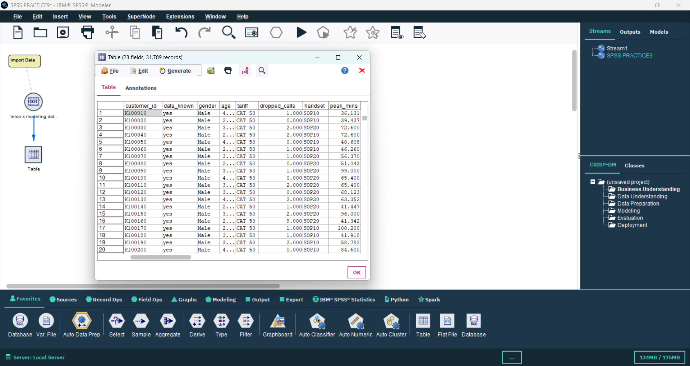

## 2. Filter Node

Filtered the dataset to include only rows where 'DATA KNOW' is 'YES' to ensure that only complete and valid records are analyzed.

📸 Screenshot:

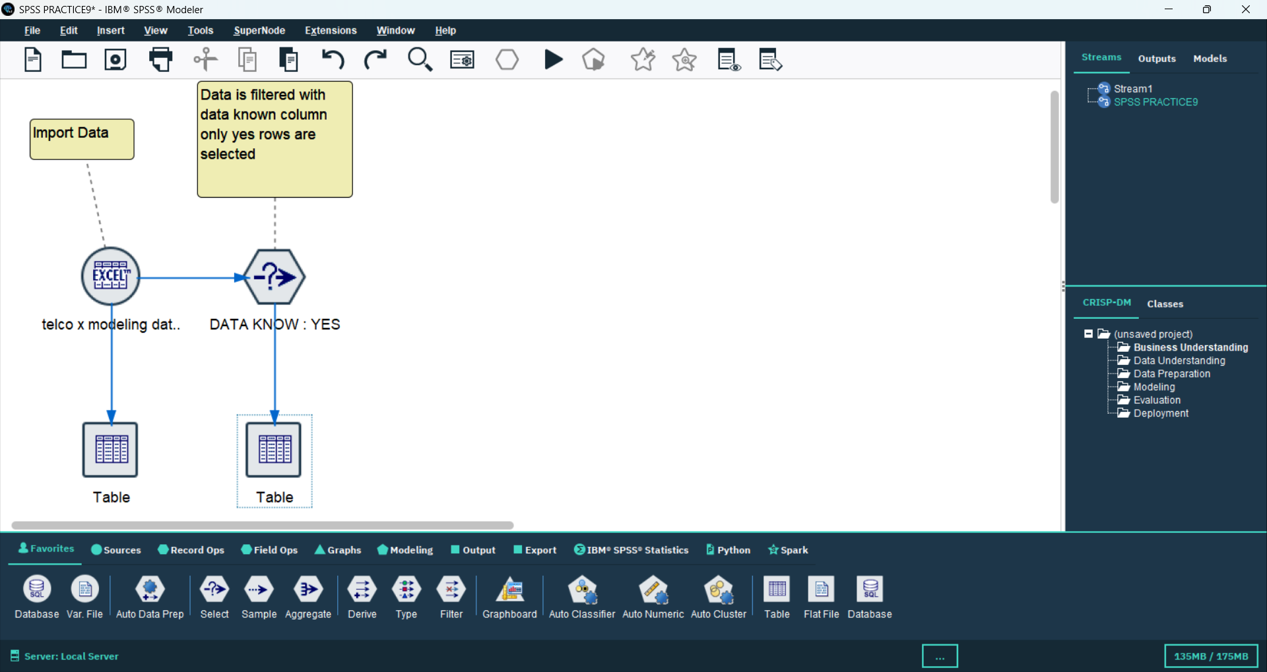

## 3. Type Node

Defined variable roles and measurement levels. Set the target field as 'churn' and assigned input roles to the predictor variables.

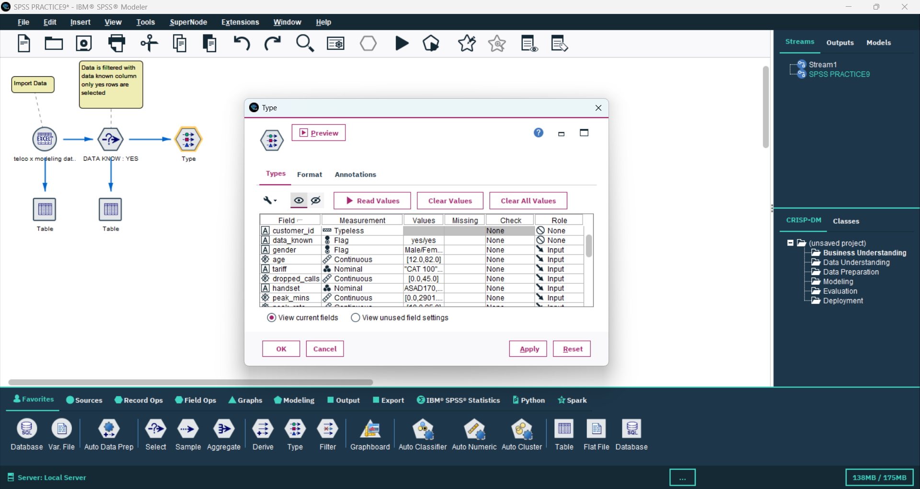📸 Screenshot:

## 4. CHAID Model Node (churn)

Built a CHAID Decision Tree model to predict customer churn. The target variable is 'churn', and other customer-related features are inputs.

📸 Screenshot:

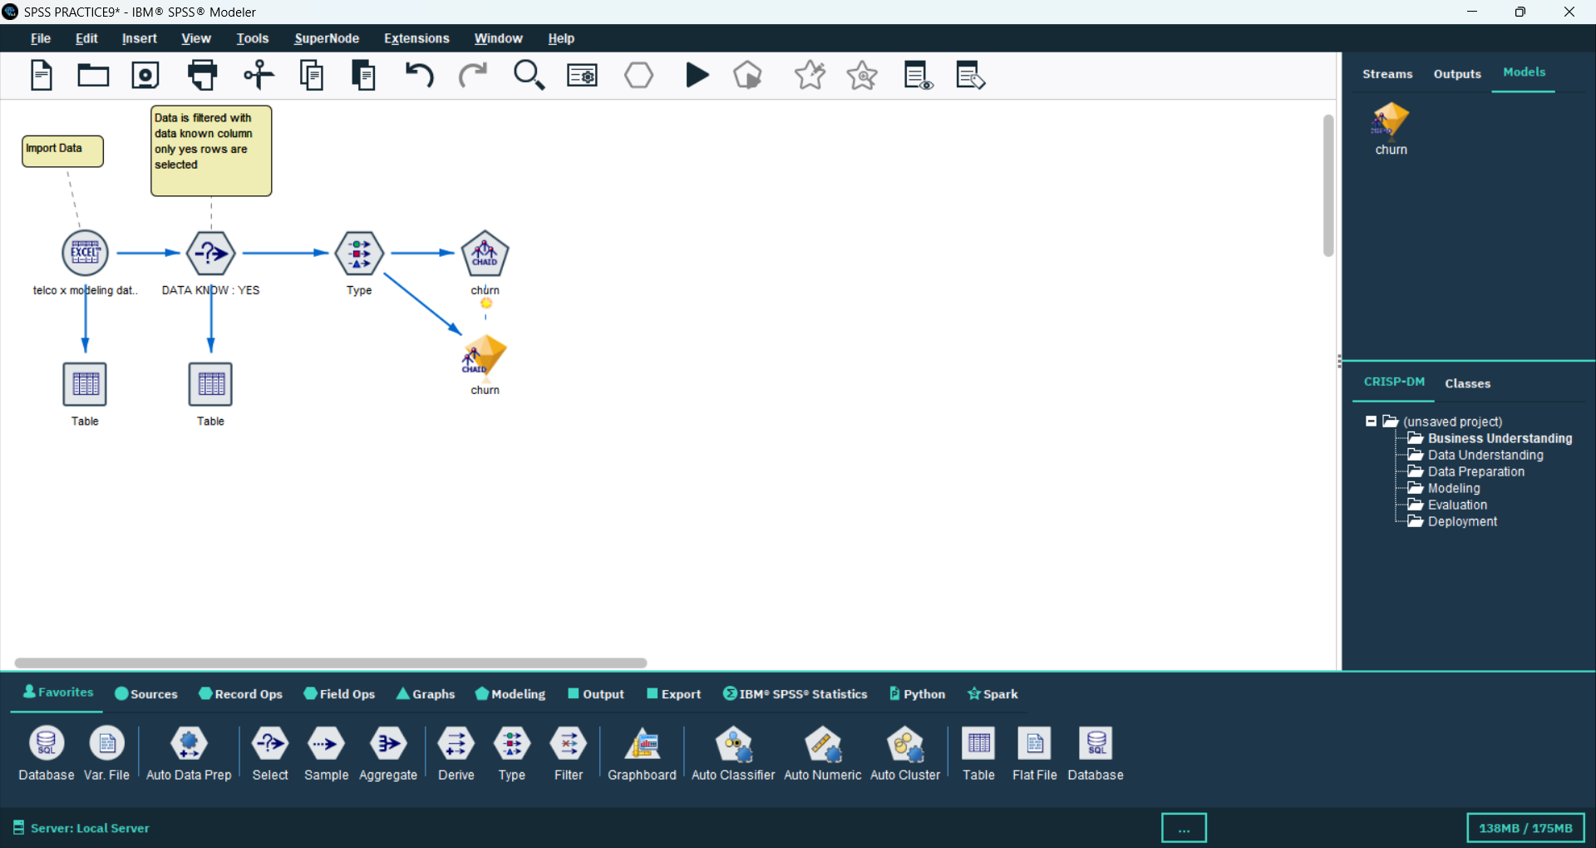

## 5. Table Node

Displayed the results of the CHAID model, including predicted churn values and probabilities.

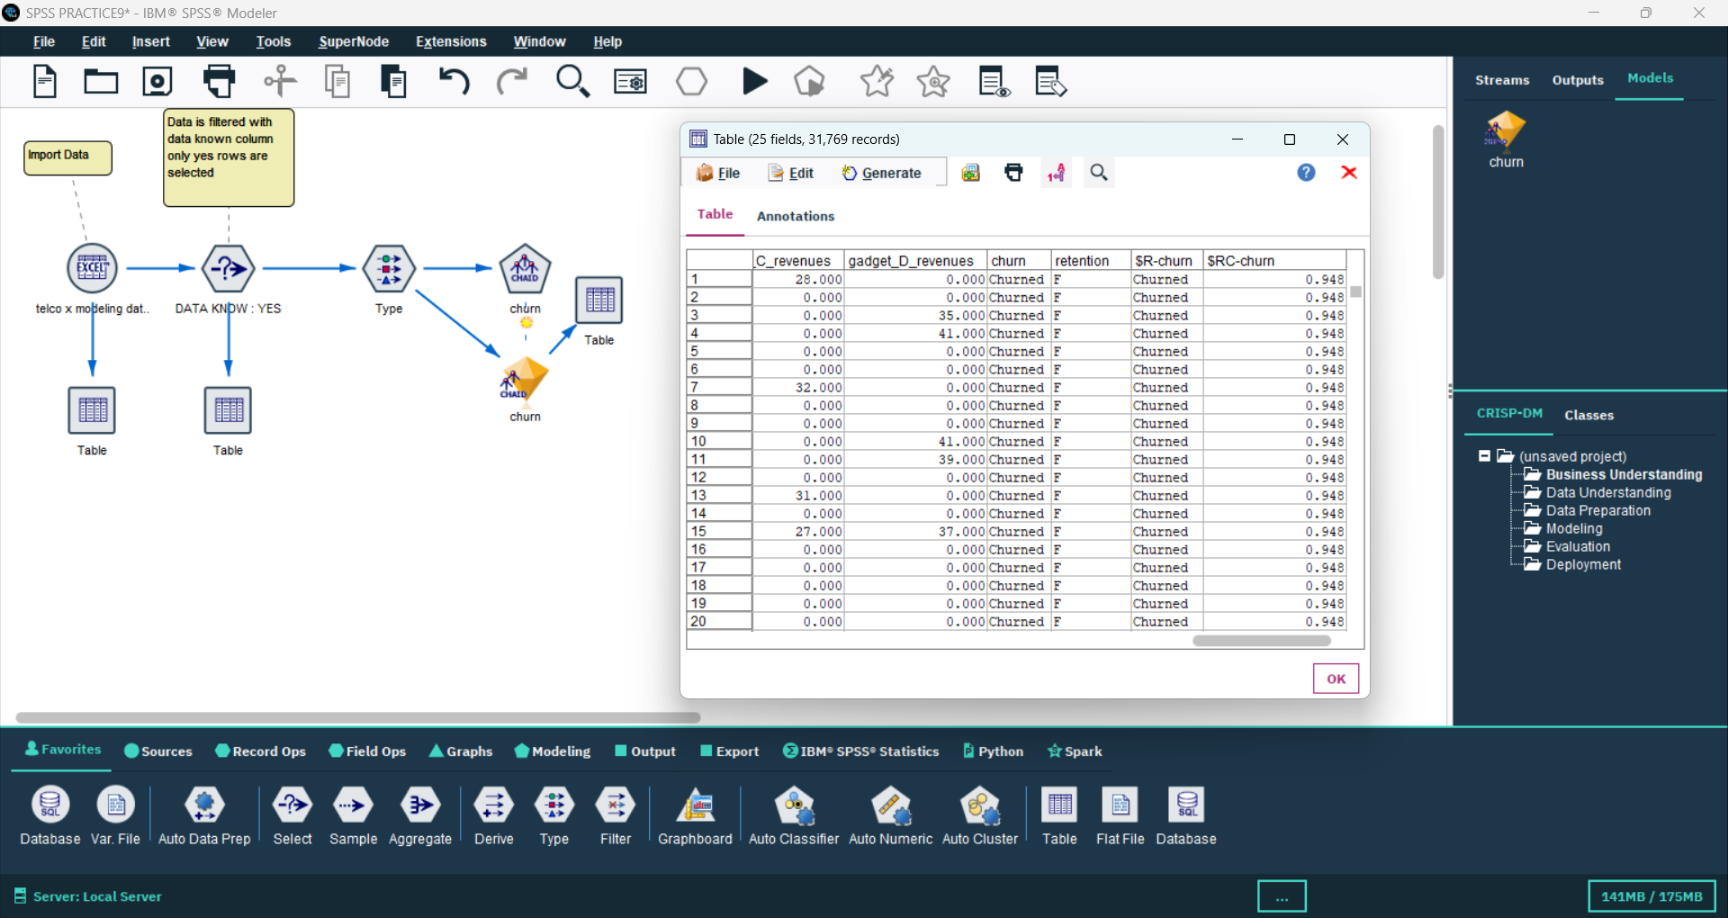📸 Screenshot:

## 6. Excel Source Node (telco x data)

Imported another dataset 'telco x deployment data' used for applying (scoring) the trained churn model on unseen data.

📸 Screenshot:

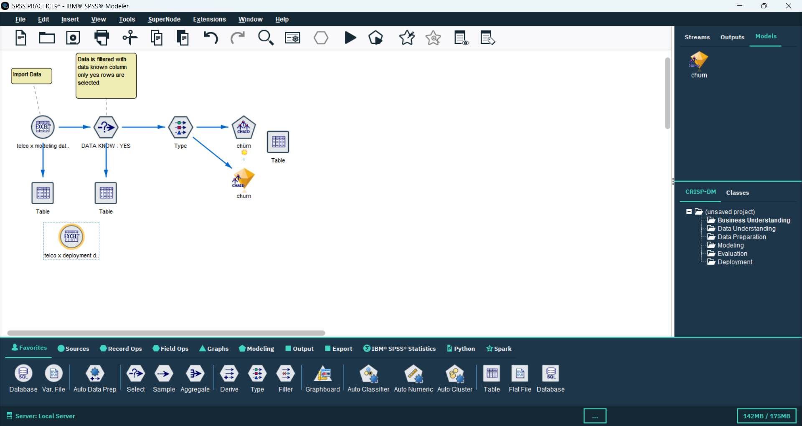

## 7. Filter Node

Filtered deployment data to include only rows where 'DATA KNOW' is 'YES' to maintain data consistency before applying the model.

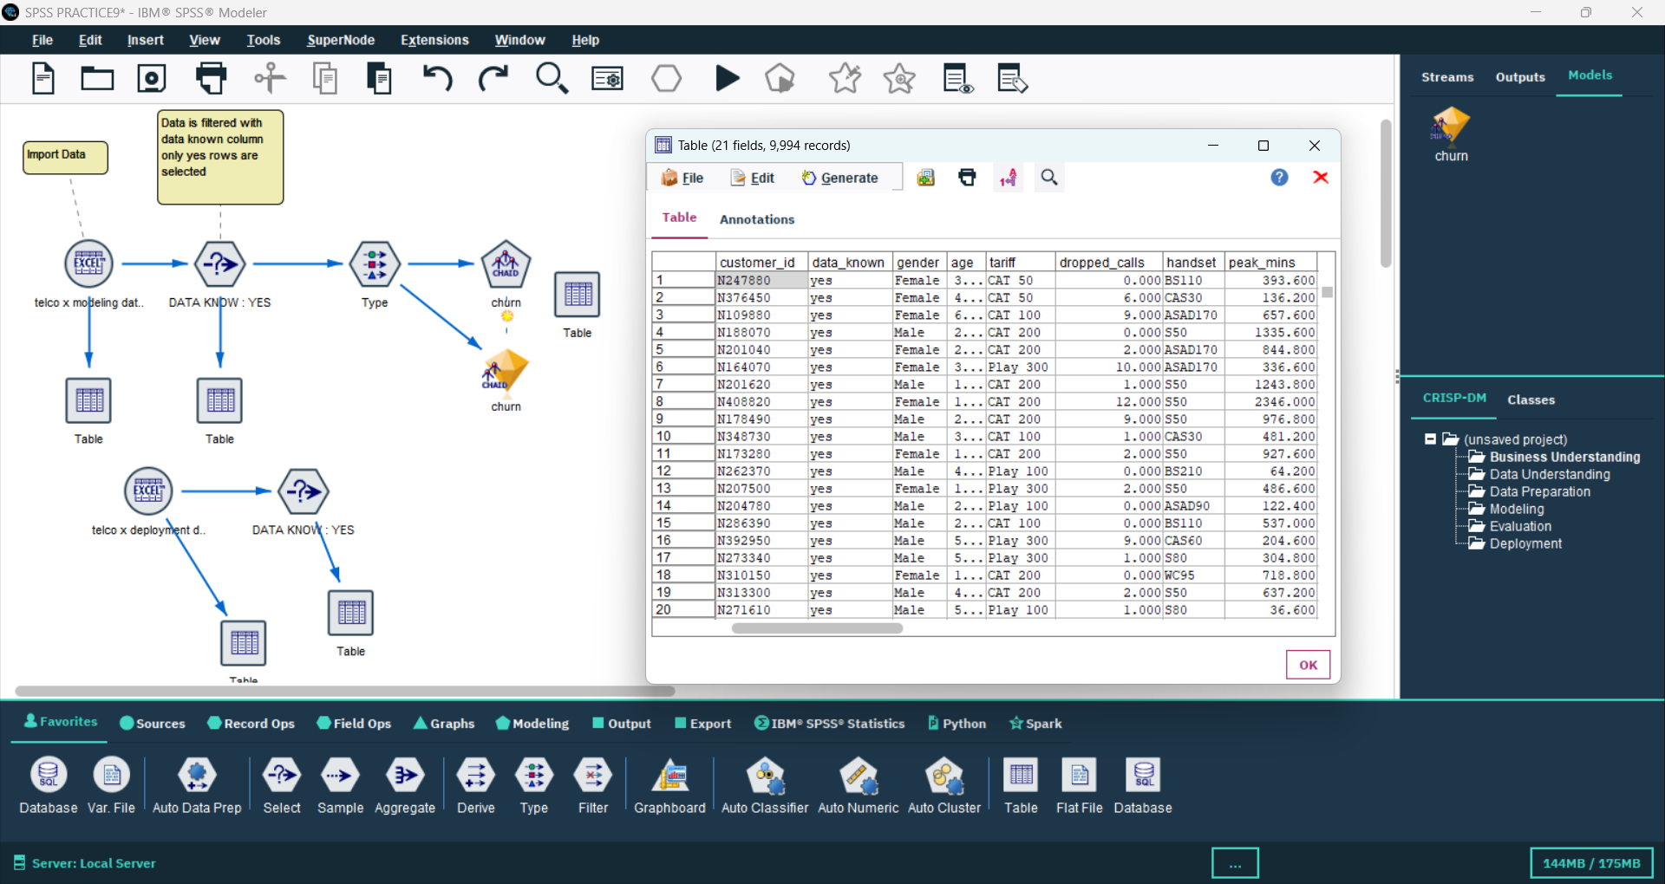📸 Screenshot:

## 8. Table Node (Deployment Data Preview)

Viewed deployment dataset after filtering to confirm correct loading and structure.

## 9. CHAID Model Applied (churn)

Applied the previously trained CHAID churn model to the deployment dataset to predict churn probabilities for each customer.

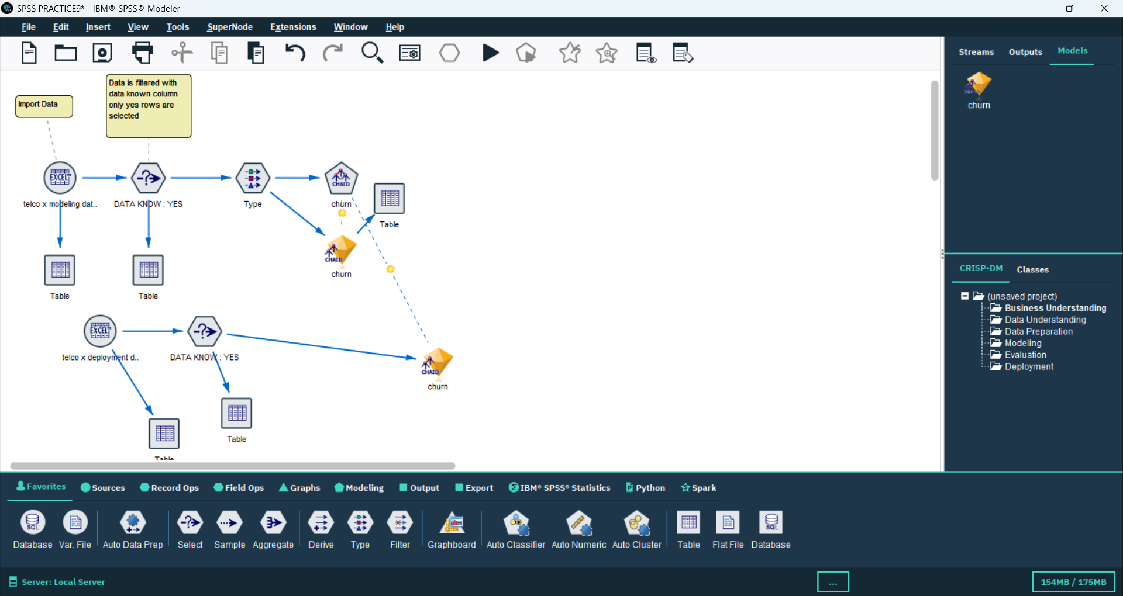📸 Screenshot:

**10. Filter Node (churned customers > 94%)**

Filtered customer data to select only customers having churn probability greater than 94%, identifying the most likely churners.

📸 Screenshot:

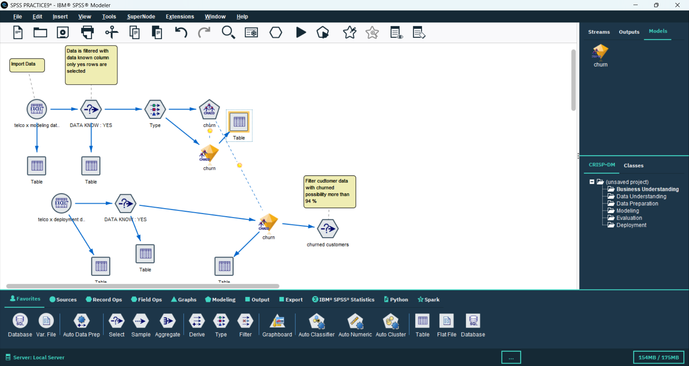

## 11. Filter Node (churn %)

Filtered and organized the output based on churn percentage for analysis and reporting.

📸 Screenshot:

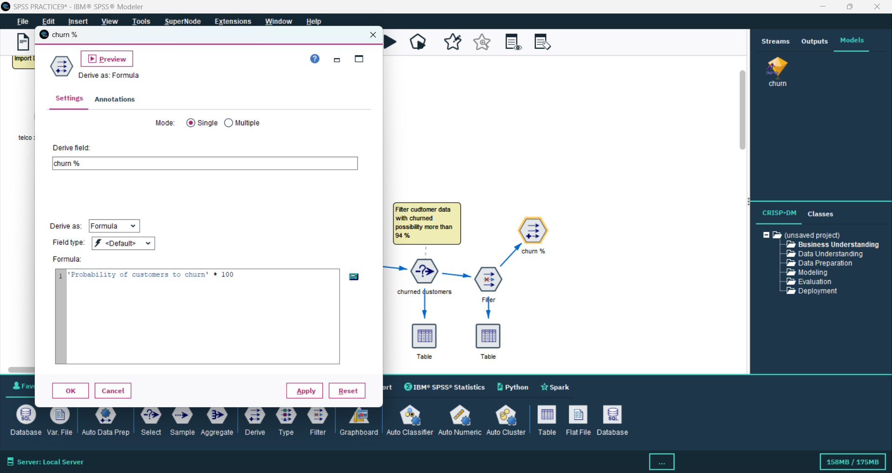

**12. Filter Nod**

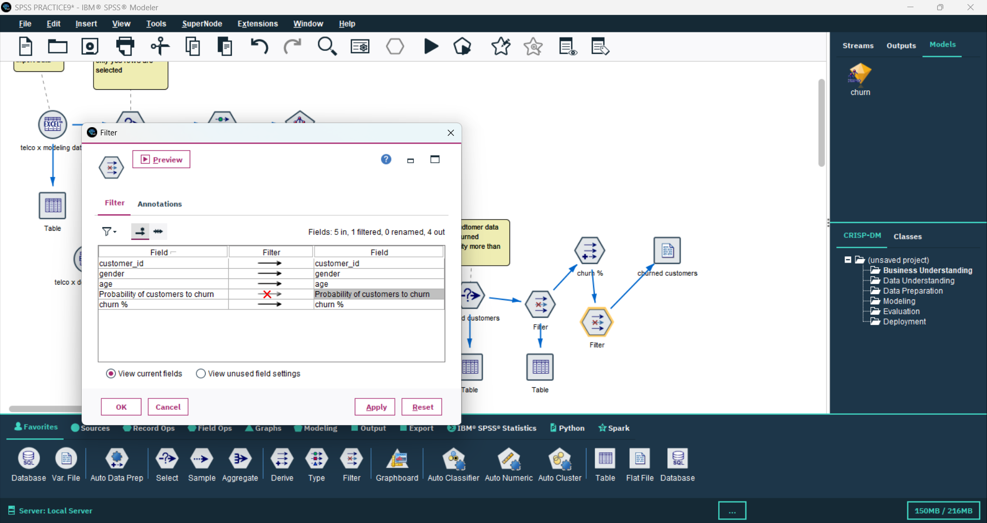Final filter applied to generate a refined list of churned customers ready for reporting

## 13. Table Node (Final Output)

Displayed the final list of churned customers with churn probability and relevant customer information for business insight generation.

📸 Screenshot:

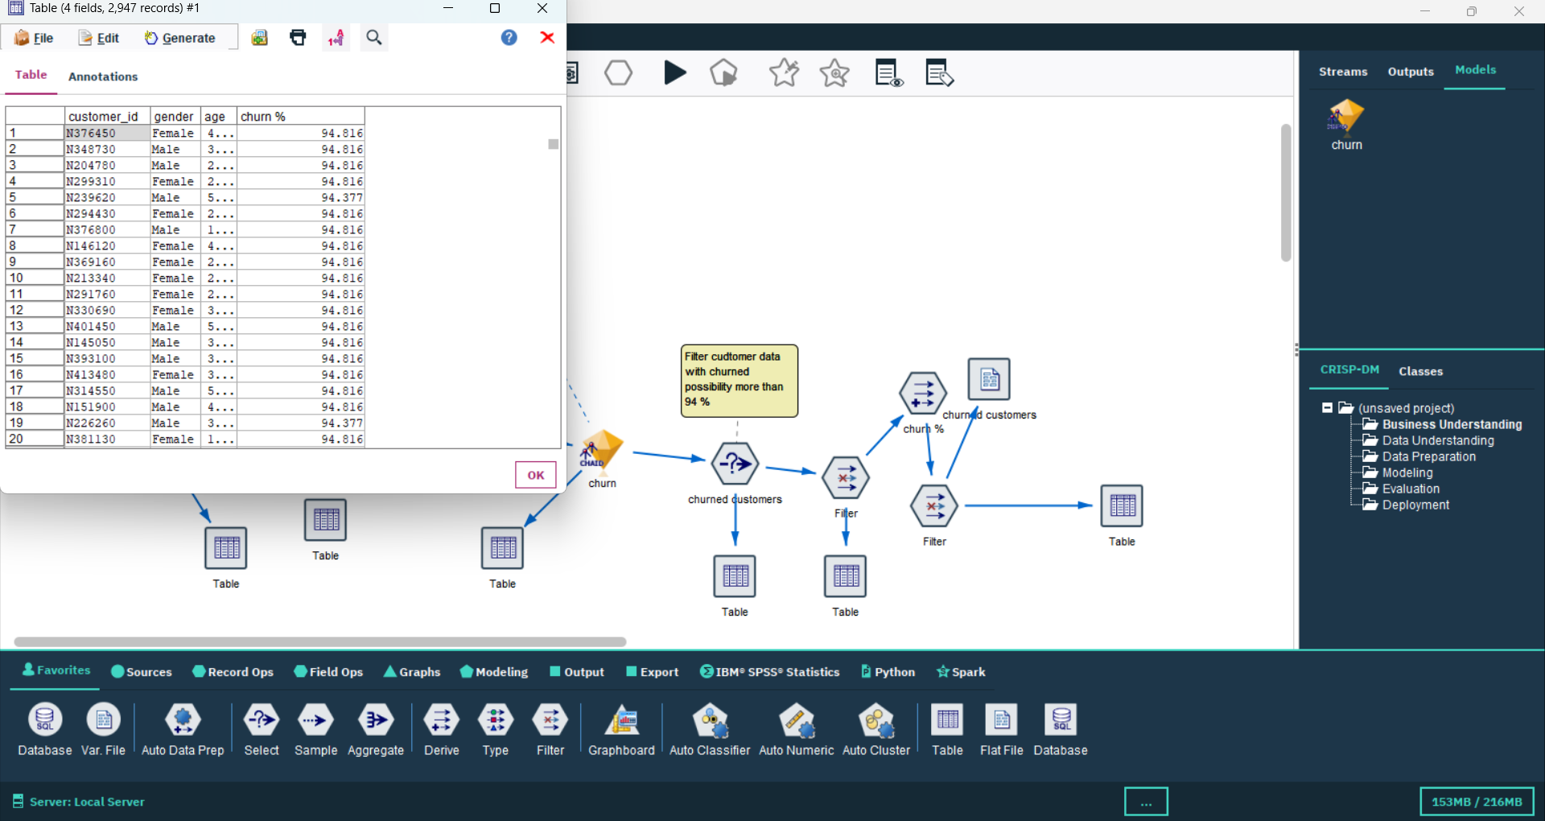

**Conclusion**

The SPSS Modeler process effectively built a full Customer Churn Prediction pipeline using the CHAID Decision Tree technique. It included steps like data loading, cleaning, preparation, model building, evaluation, and identifying customers with a high likelihood of churn. This approach enables businesses to detect at-risk customers and take focused actions to improve retention.